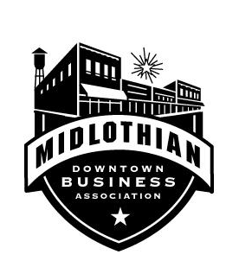

MEMBERSHIP ADVANTAGES
Thank you for thinking about joining the Midlothian Downtown Business Association. This Association is a non-profit 501c Association that is based on enhancing businesses and the historic area of Midlothian. This Association will allow you an opportunity to promote your company, while improving the business climate and supporting events that contribute to an excellent quality of life in Midlothian.
Marketing Advantages:
- Advertising opportunities in our events
- Low cost marketing opportunities through social media
- Sponsorship opportunities for events
Networking Advantages:
- Committee participation opportunity
- Networking opportunities with other businesses through events
Advantages of Membership:
The Midlothian Downtown Business Association also offers opportunities for members to help plan, sponsor, and/or participate in some of the community’s largest events:
- Downtown Midlothian Market
- Scarecrow Festival
- Heritage Day Event
- Annual Fund Raiser/Celebration
New Members Receive:
- Recognition on social media
- Member welcome, welcome package and membership decal

Midlothian Downtown Business Association is a 501 c non-profit

Contact information:
MDBA Office
117 N 8th St Suite C
Midlothian, TX 76065
Email: Midlothiandba@gmail.com

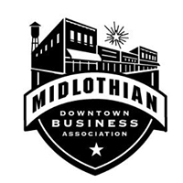

ANNUAL MEMBERSHIP APPLICATION

BUSINESS INFORMATION:

Company Name:______________________________________________________

Primary Contact Name: _____________________________________________

Phone Number: ______________________________________________________

Physical Address: ___________________________________________________

Mailing Address: ____________________________________________________

_____________________________________________________

Email: ________________________________________________________________

Membership Options:

__________Corporate Membership $500.00

_______Business/Property Owner Membership $200.00

__________ Tenant Membership $100.00

__________ Supporter Membership $50.00

Midlothian Downtown Business Association is a 501 c non-profit

Contact information:
MDBA Office
117 N 8th St Suite C
Midlothian, TX 76065
Email: Midlothiandba@gmail.com

Receipt for Annual Membership

Date: ______________________________

Recevied by:

Payment Type:

Total Paid:

Midlothian Downtown Business Association is a 501 c non-profit

Contact information:
MDBA Office
117 N 8th St Suite C
Midlothian, TX 76065
Email: Midlothiandba@gmail.com

